**Course : Mobile Computing**

**Instructor Name : Sir Haq Navaaz**

**Name : Ahmad Nadeem**

**Roll Number : bsef18a033**

Making a new repository on git hub,

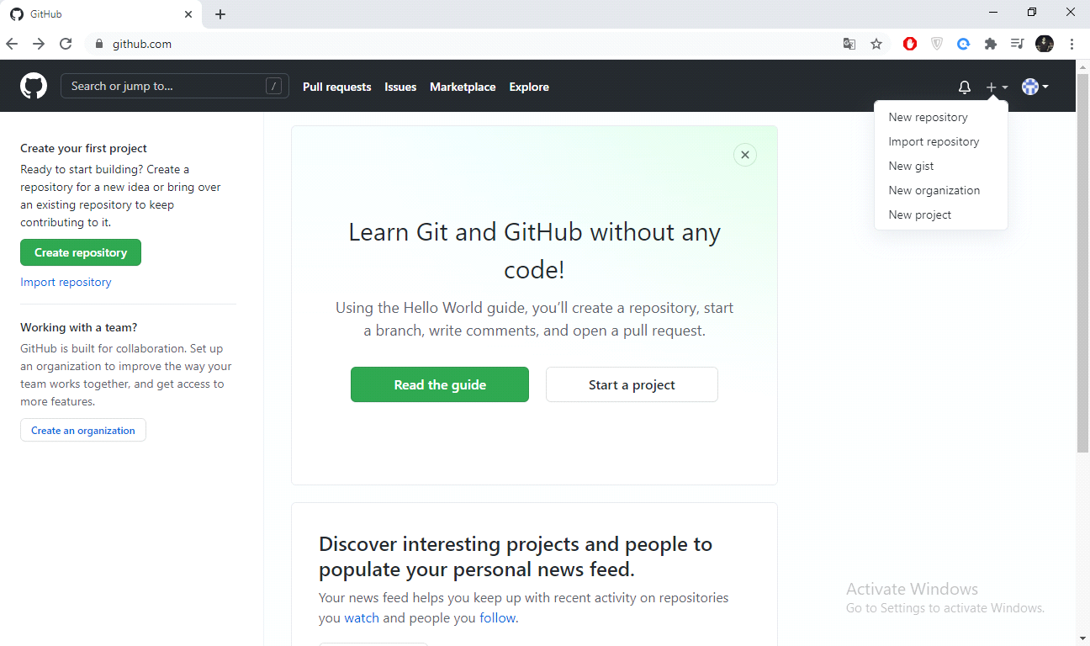

Click on that symbol '+' at the top right and then click on the 'New Repository' to create a new repository.

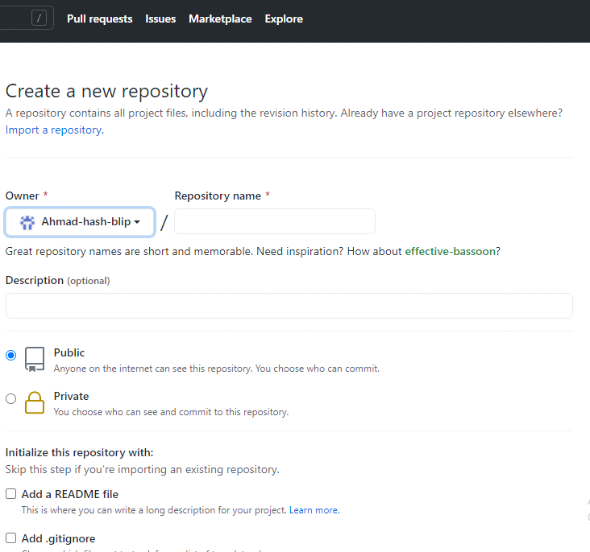

Add name to your repository by which it will be uniquely identified and then click on public if you want other users to see your repository and private if not.

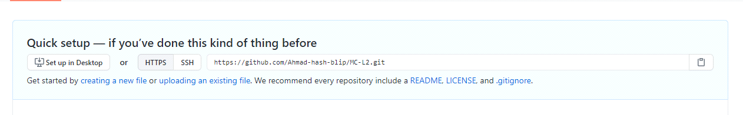

After giving name this will be the URL for your repository on github. Now clone your central repository in any of the local directory.

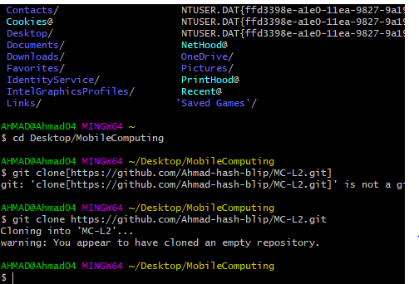

Now open some IDE for creating a file. For opening code write this on bash terminal.

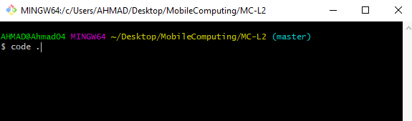

After that your visual code will get open , then make a file name MC01.html there and save it in the clone file of your repository.

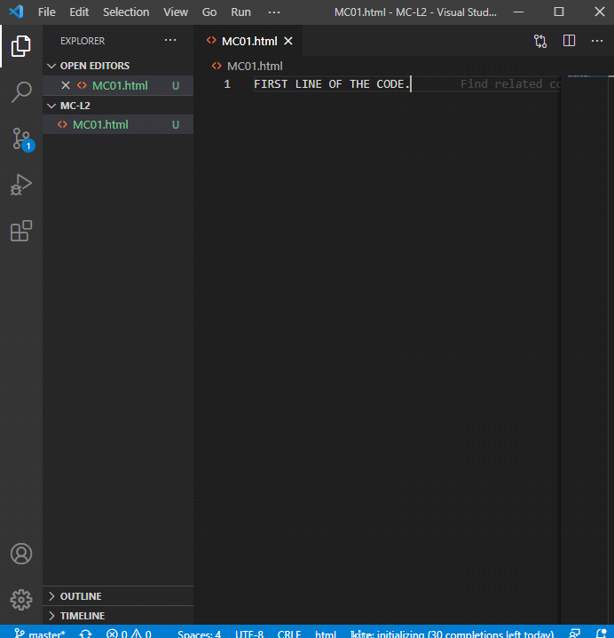

Now add this file to the staged area so that git gets track of that file. And after adding file take a snapshot of that unmodified file by commiting it.

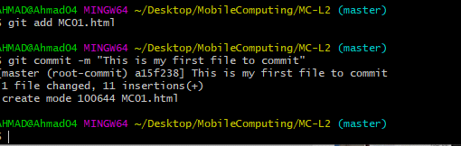

After that push this file to the VCS by using the command below.

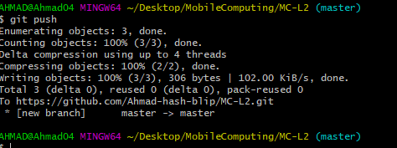

Now it should appear at your central repository like this,

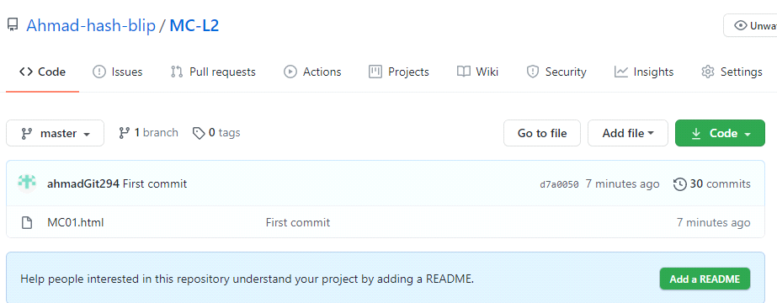

Above is the file name along with the commit message "First commit". Now we are making a change at our file and checking status at bash.

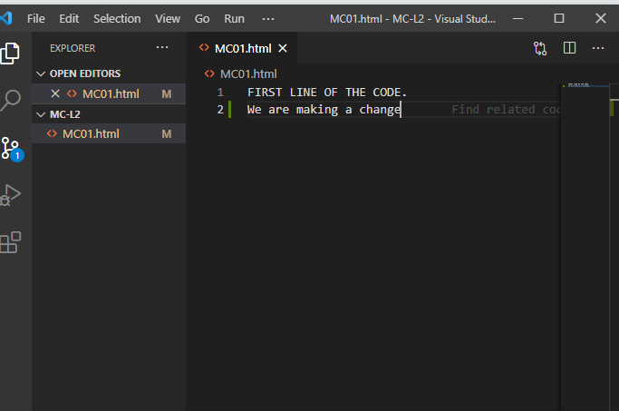

and the status command shows that,

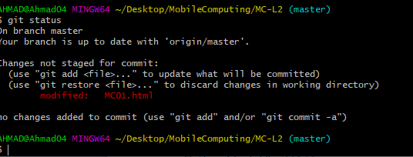File MCM01.html is modified and needed to be commited. Now we add and commit it and then push it in github

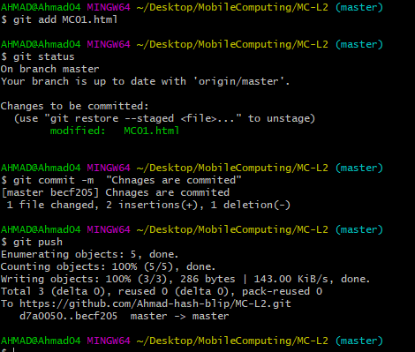

and this change will also apppear on the github like this,

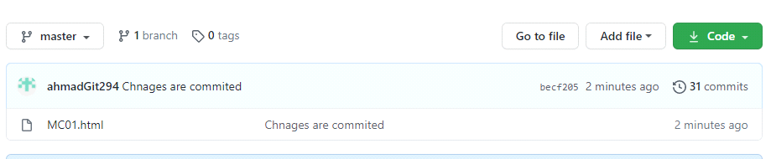

For editing this file on github click on the file and then click on the edit option near to the right corner of the file

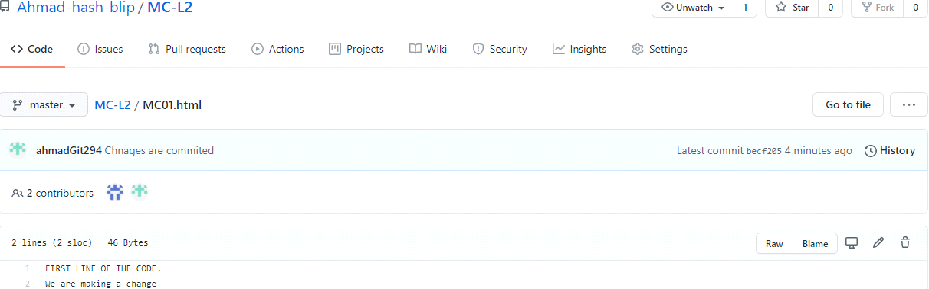

After clicking on the edit button an online compiler will get open and edit it there like this,

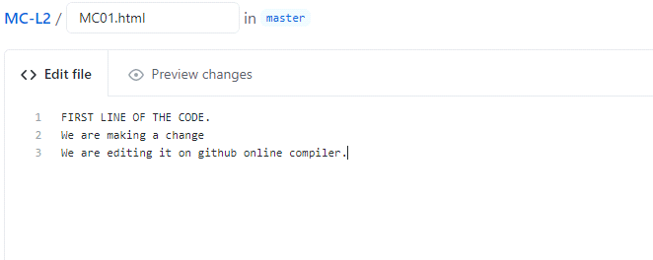

And now scroll down this page and there will be a green commit button and press it to commit in the master branch.

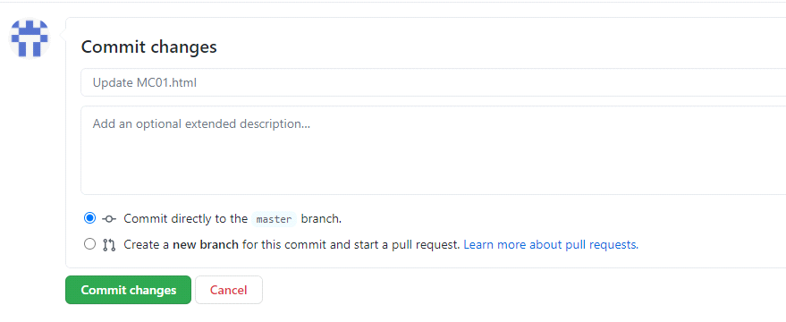

After committing changes will start appearing on the file content in github.

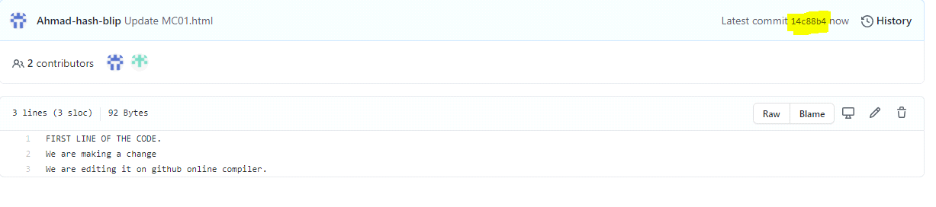

The yello highlighted area there will show the number of this file snapshot by which it will be uniquely identified. By clicking on that alphanumeric number the hierarchy will appear like this,

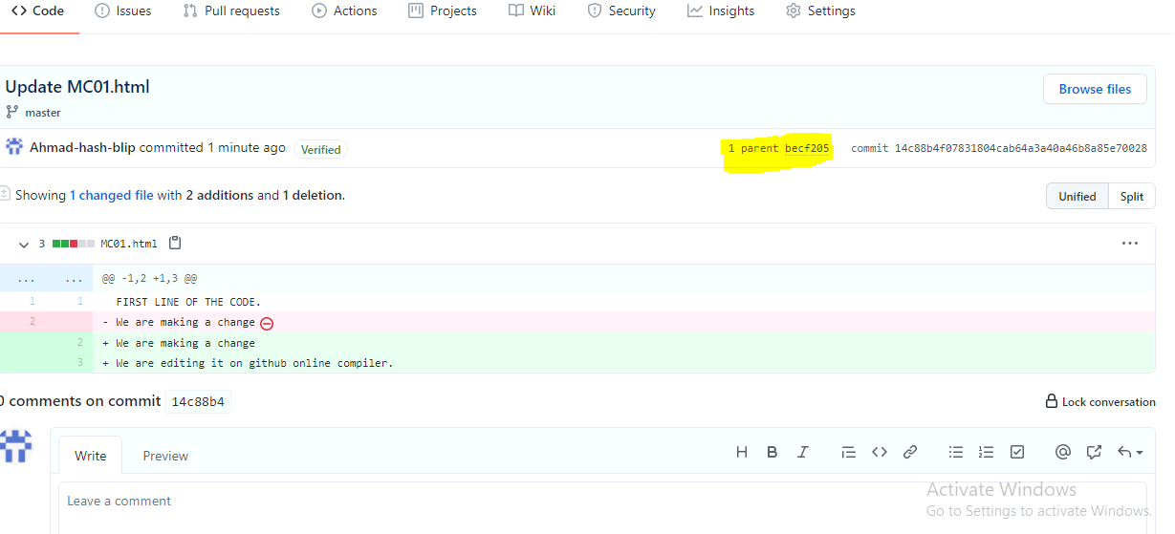

It shows this has one parent and on clicking on parent previous file will appear. When it shows 0 parent it means that this is that starting origin file. Now the changes we made at the file at github compiler, if we want to make them on the original file also then we need to pull these thing by using command like this,

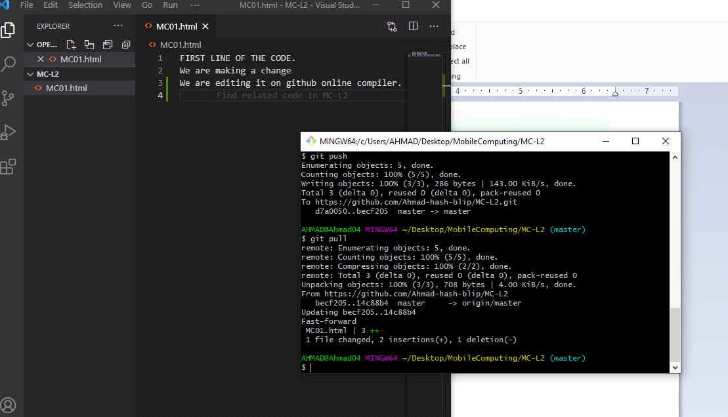

No if we make a file change at gihub by editing it

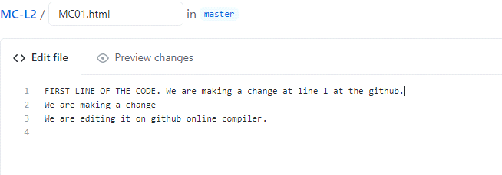

And then commit it like,

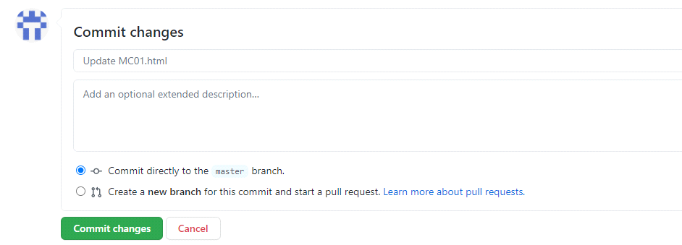

Then its content will become,

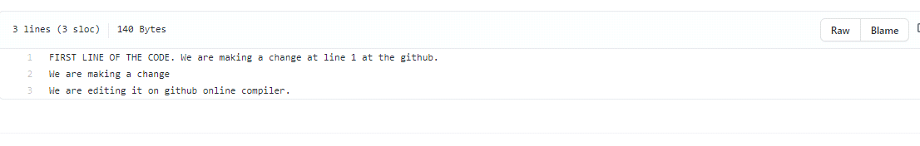

Now if we make a change at file in visual code,

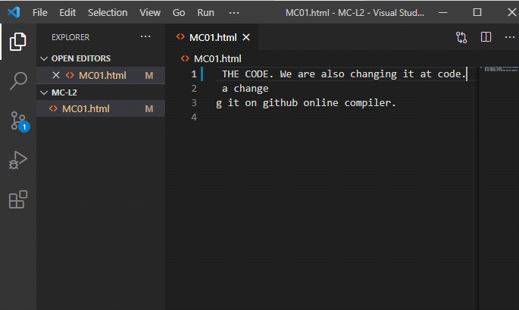

and after saving it we add annd commit and pull the changes from github,

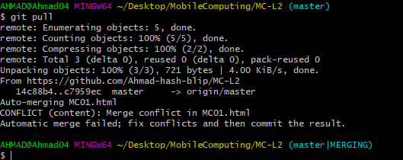

a merge conflict will appear like this ,

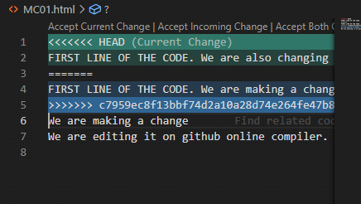

because we without pulling chnages from git we committed more changes at the same line now we have to chose incoming or current or bith chnages by clikcing on the hover.

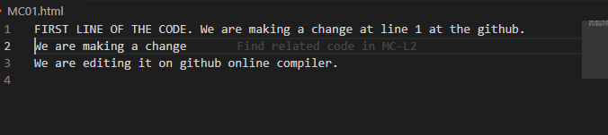

This will appear by accepting incoming chnages, now iwe have to push this change to github for synchronizing local and central repositories.

If we want to know about different works and log there is a command like this,

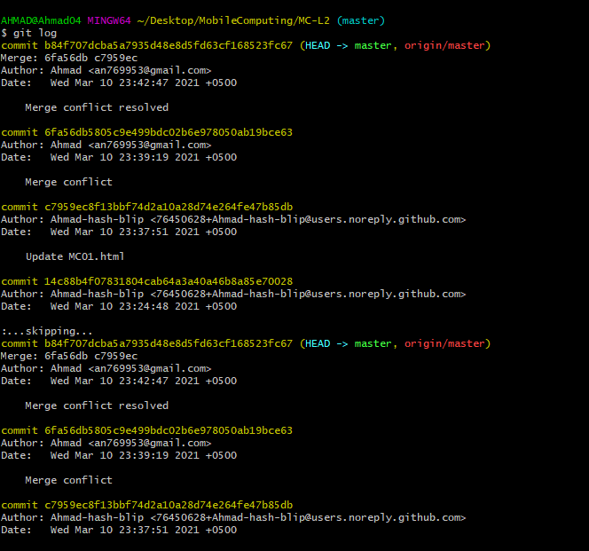

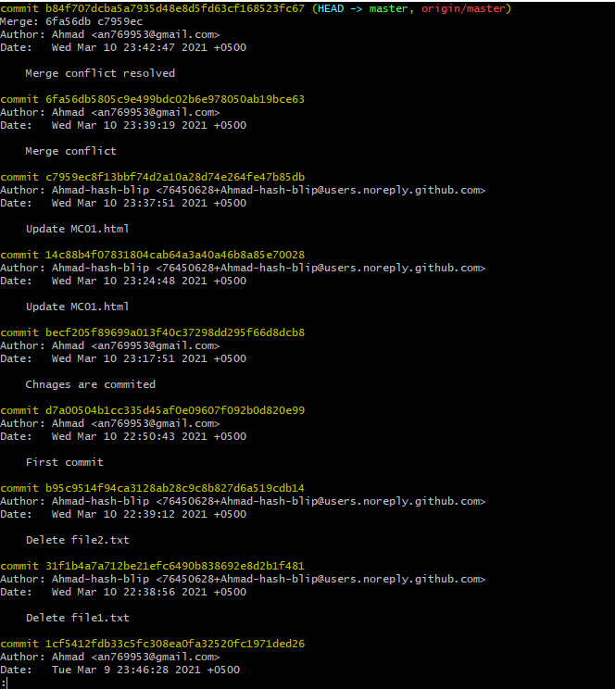

These are several details about email name commits etc. and can be very useful. Now we make 3 text files.

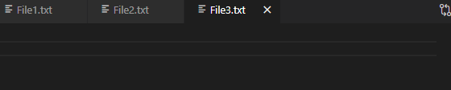

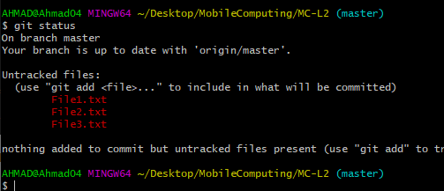

These are 3 untracked files here and we need to commit them. Now we add them all and commit them snd thrn pudh them to github.

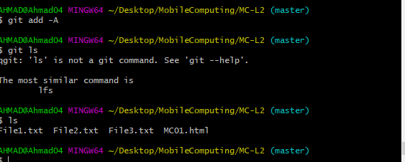

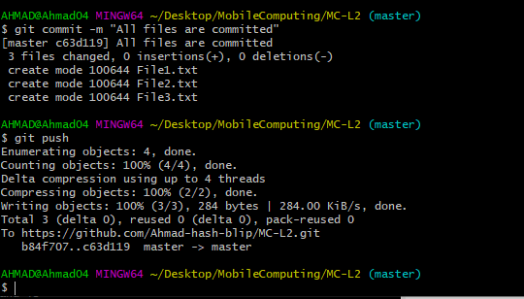

These will appear in Version Control System like this,

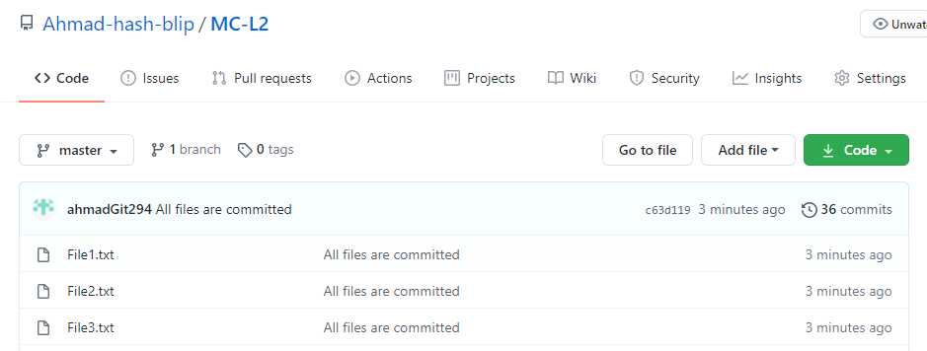

Now if we run remove command on the terminal for file3 and them add changes and then commit and push them to git , the subject file will be deleted.

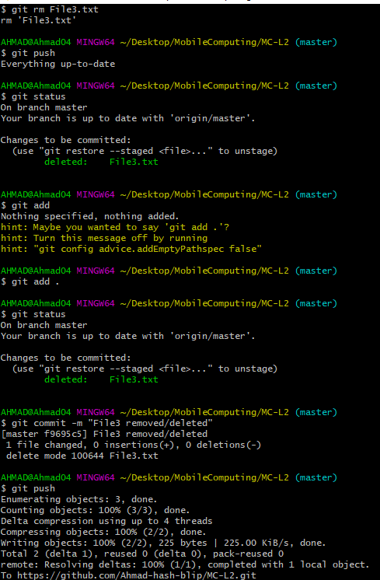

The file will be deleted from github,

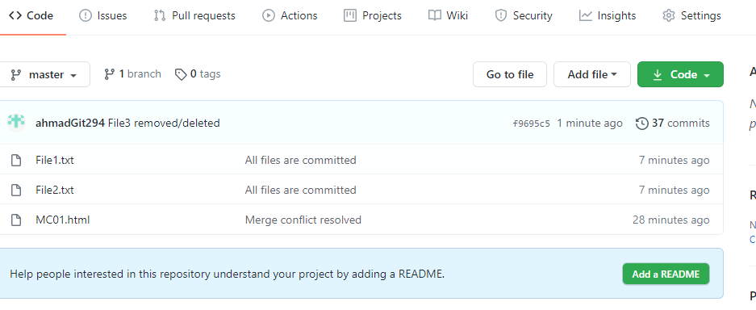

If we want to check our branch and make a new branch and switch branch we execute following commands,

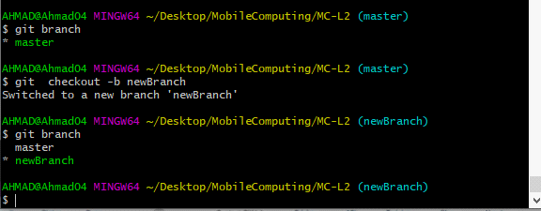

If we make some changes in the file in newBranch and add, commit it ,



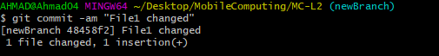

These changes in code are,

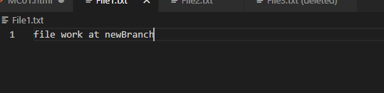

now if we swicth branch changes in this branch will vanish and subject branch state will be retained,

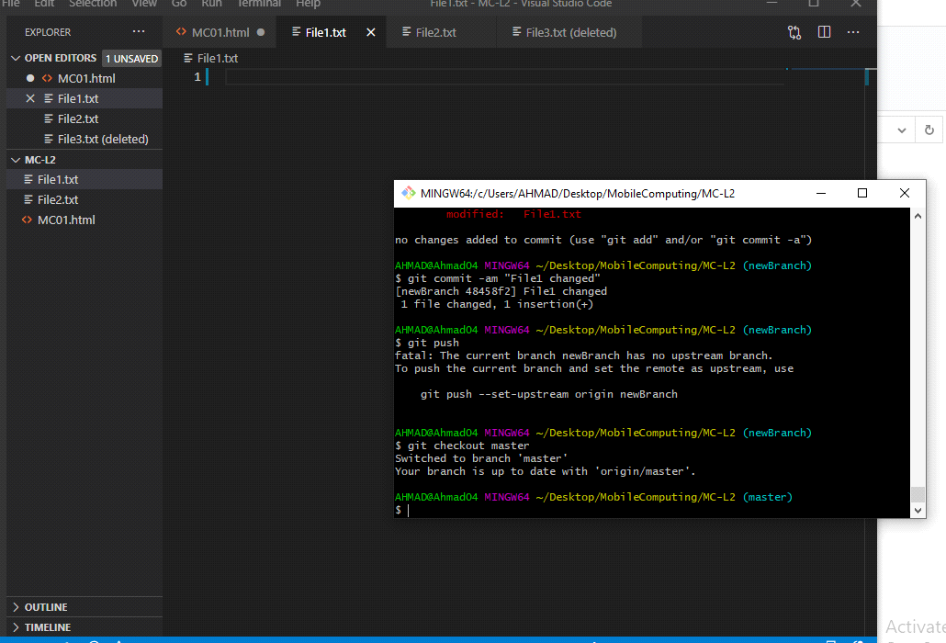

Now if we want to merge master and new branch and then delete new branch after using it then we have to ,

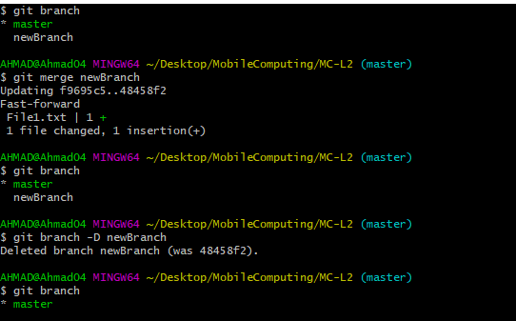

And visual code will look like,

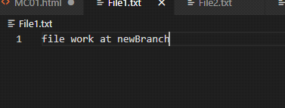

Now we have to add , commit and push the file to the github,

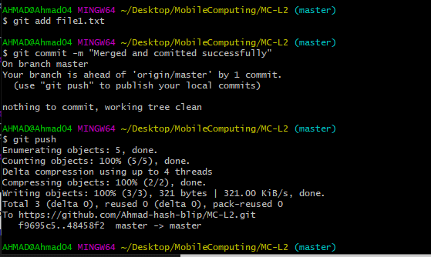

**NOW WE GOING THROUGH ANDROID STUDIO,**

Click on the new project option for creating a new project,

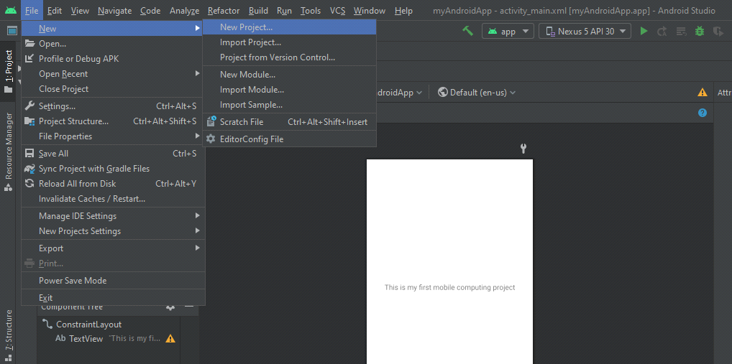

Then select empty template and click next,

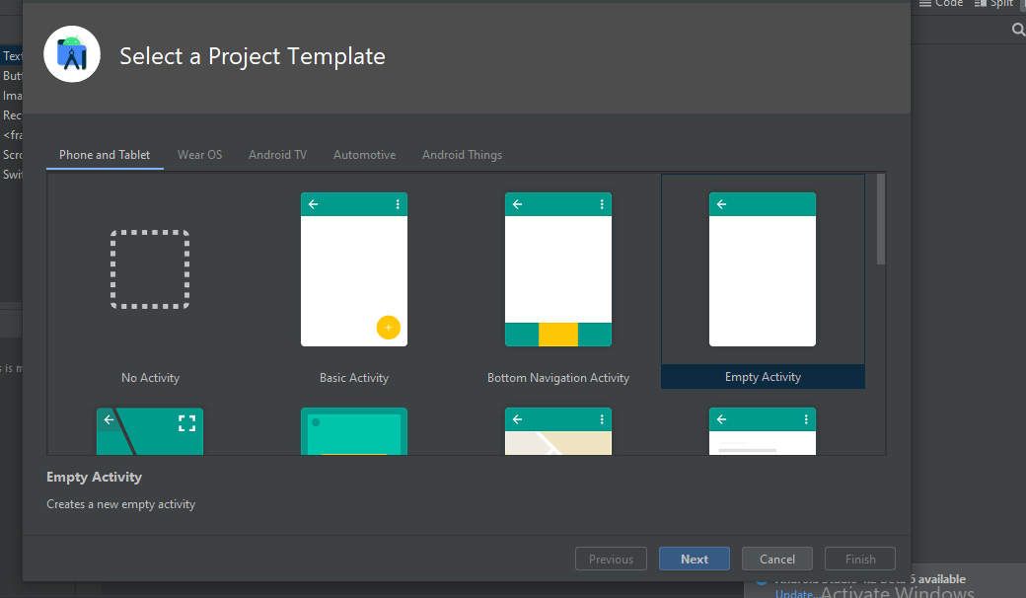

Next will bring you to these requirements,

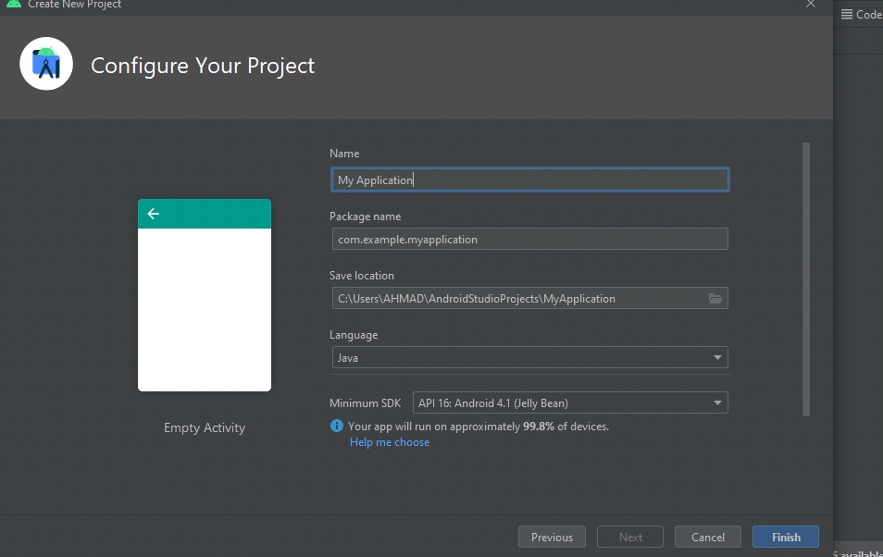

Enter name of your project and package name by which your package will be recognized and location of your project and select language and SDK according to your requirement.

Now , the designing interface is like,

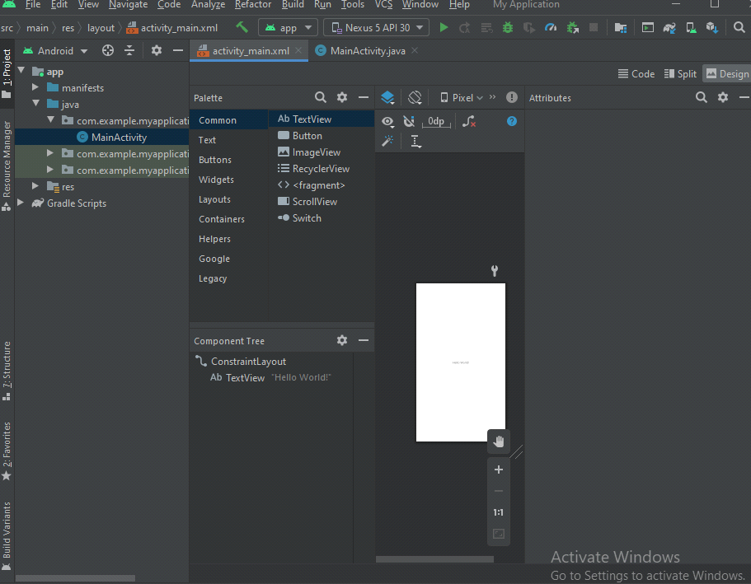

And coding screen is like,

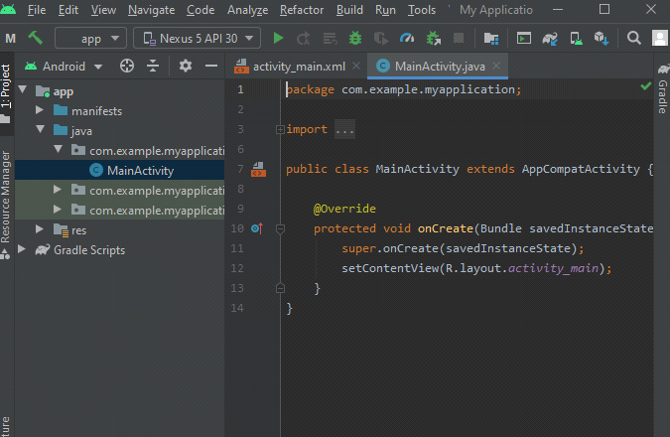

If we try to use the IDE just for an idea , i just added a Text-View and a button-view,

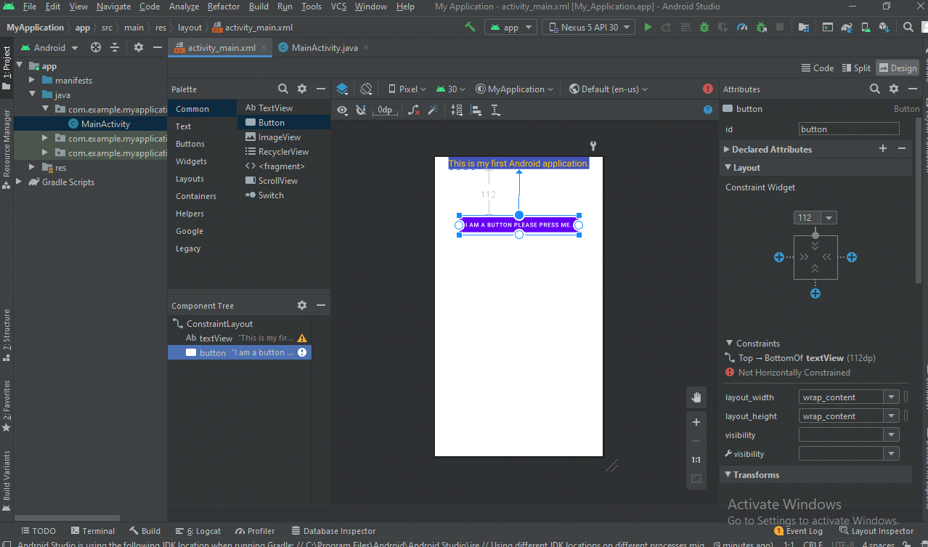

and its emulator display is ,

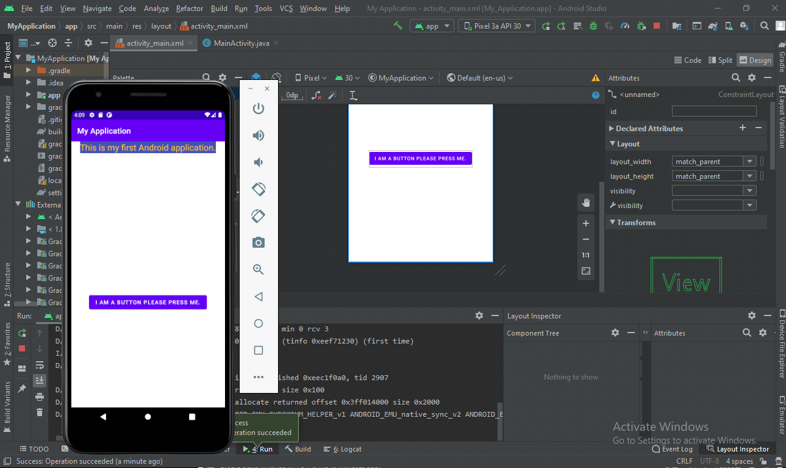

**NOW WE ARE GOING TO ADD NEW .XML FILE IN CONSTRAINT LAYOUT,**

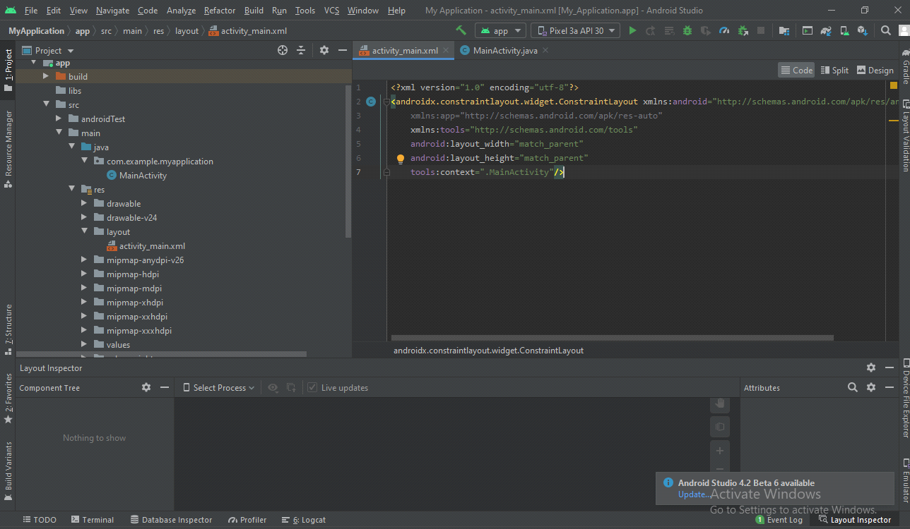

This is the constraint layout and to add .xml file with constraint layout as a root viewgroup we will do that,

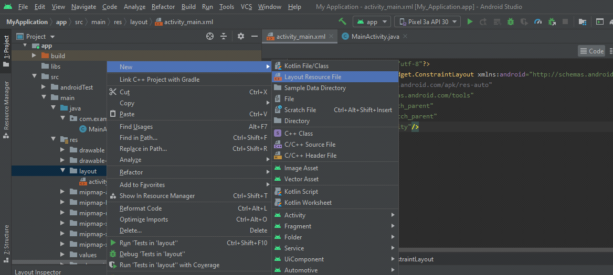

After clicking on this we will add name,

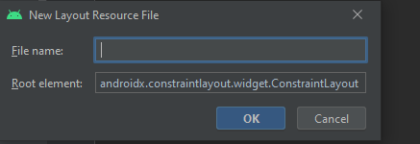

After that declaration of name our newly created .xml file will be

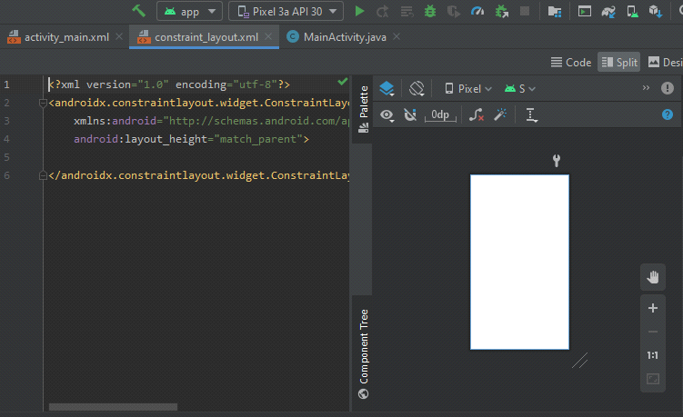

Now to code and to make our views functional in this newly created contraint layout we have to change setContentType in MainActivity.java file like this,

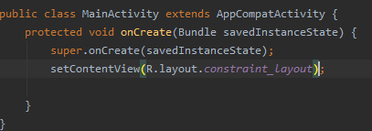

This will be our constraint layout file,

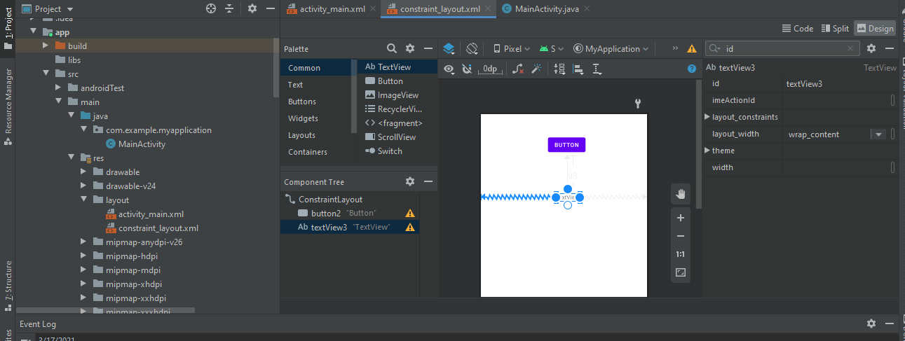

If we want to add imageView ,

